**TO IMPORT DATASETS**

import os

import pandas as pd

os.chdir("C:/Users/PC/Documents/dataset")

data = pd.read_csv("product1.csv")

data

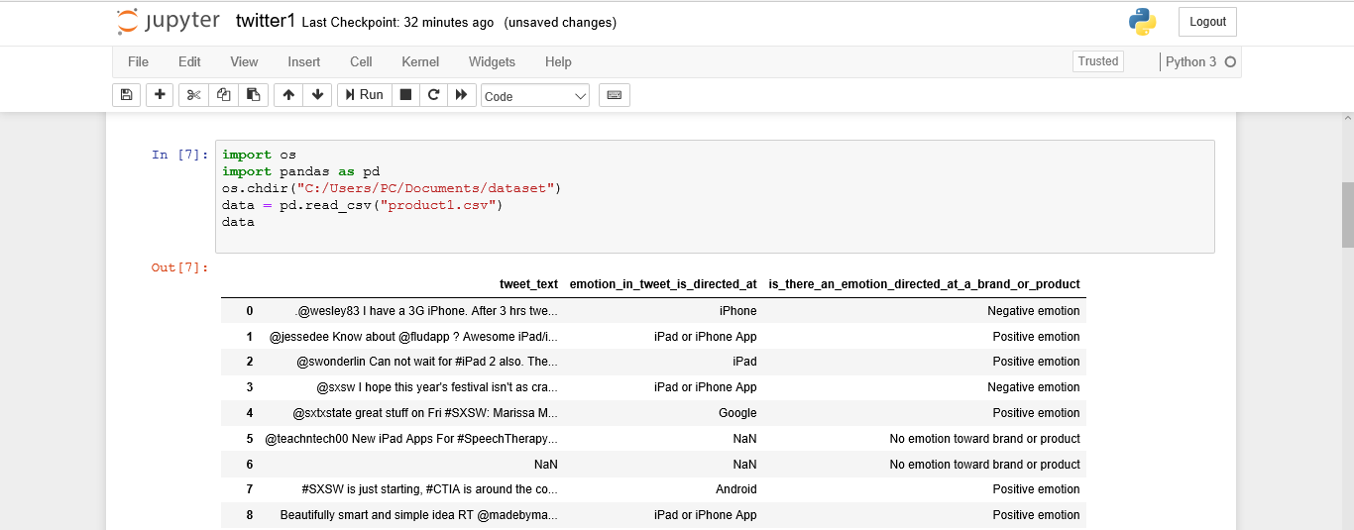

print (data['emotion_in_tweet_is_directed_at'])

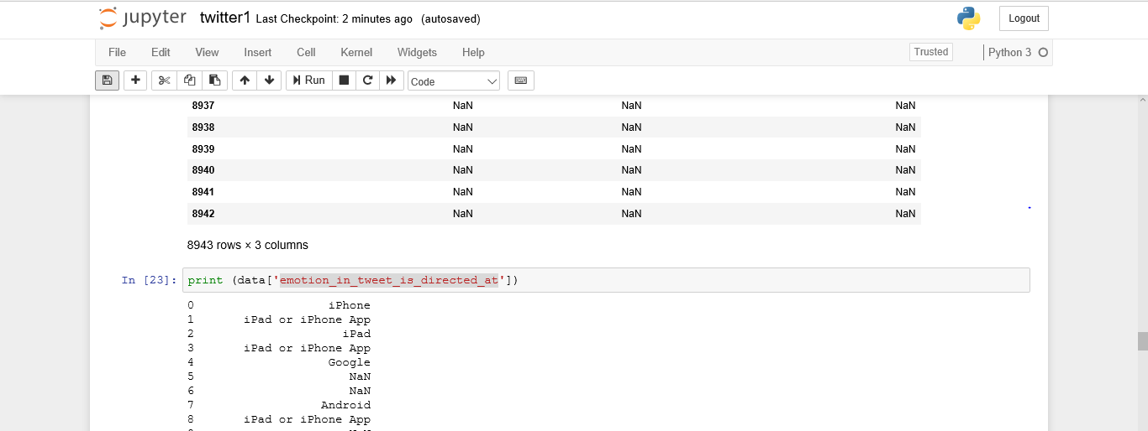

data.apply(lambda x: x.count(), axis=1)

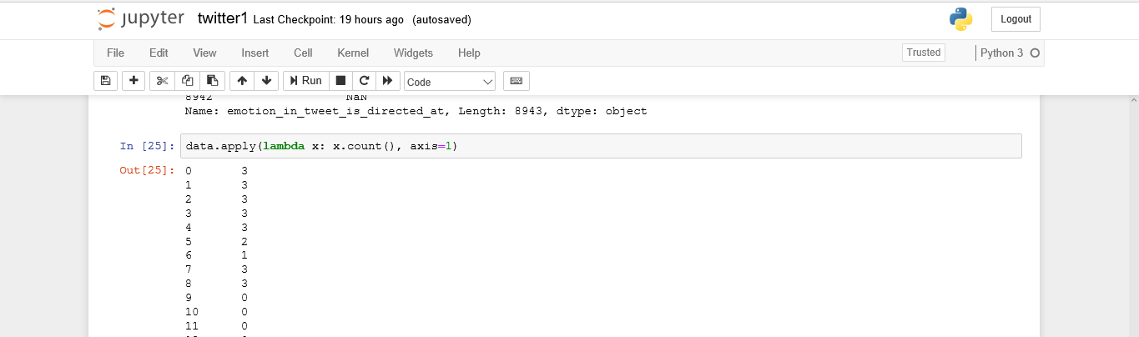

print (data['emotion_in_tweet_is_directed_at'].isnull())

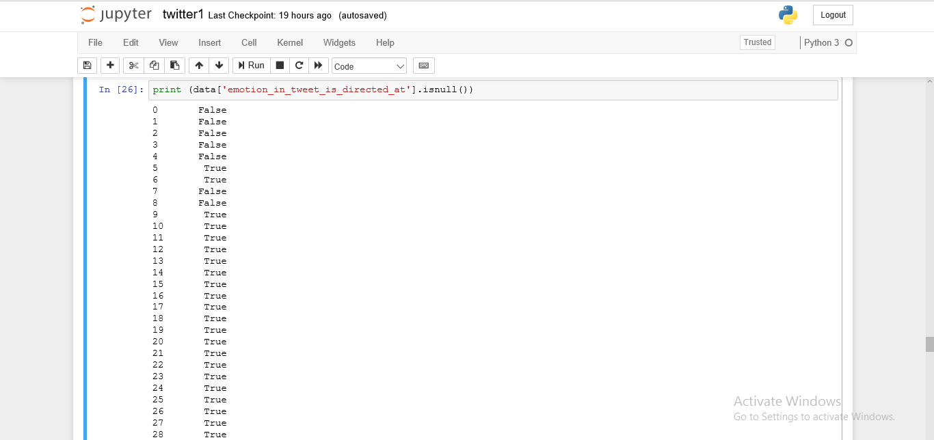

missing_values = ["n/a","na","--"]

os.chdir("C:/Users/PC/Documents/dataset")

data = pd.read_csv("product1.csv",na_values = missing_values)

data.isnull()

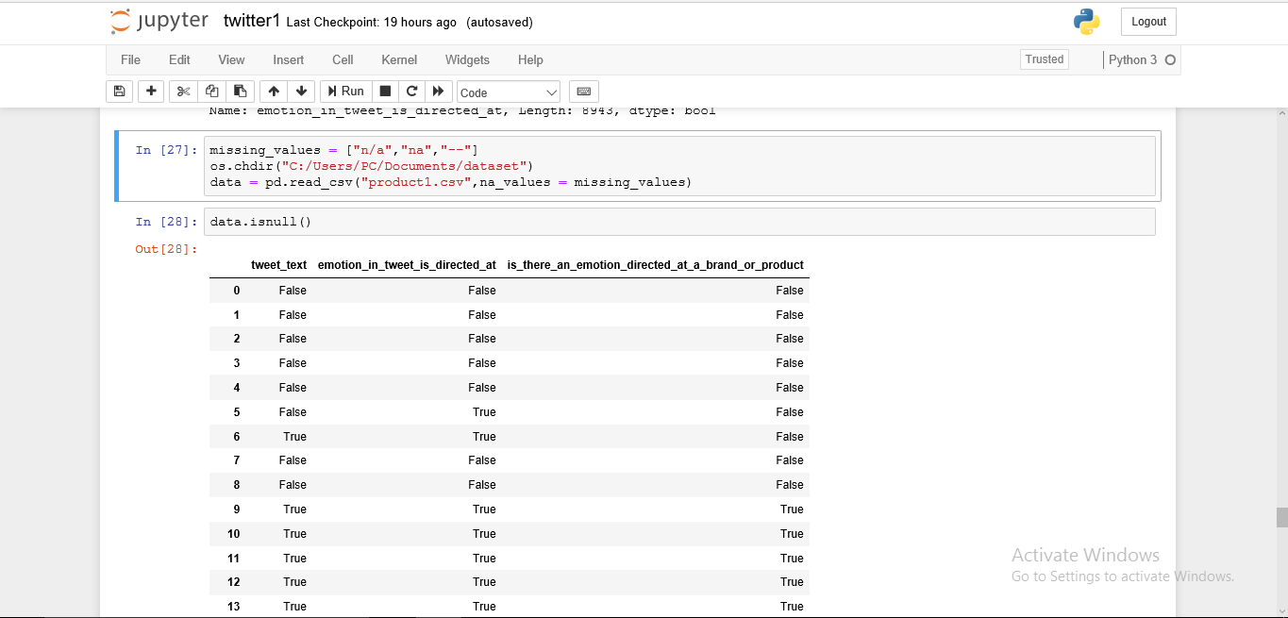

cnt =0

for row in data:

try:

int(row)

df.loc[cnt]=np.nan

except ValueError:

pass

cnt+=1

print (data.isnull().sum())

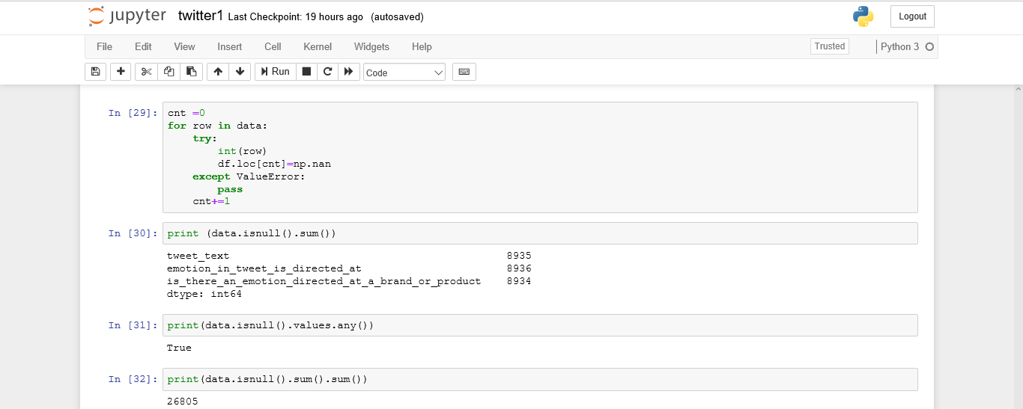

print(data.isnull().values.any())

print(data.isnull().sum().sum())

data["emotion_in_tweet_is_directed_at"].fillna("0",inplace = True)

print (data.isnull().sum())

